

ServiceNow Package

# Readme

Version 1.0

09/24/2021

Table of Contents

1. Introduction 3

1.1 Overview 3

1.2 Use Cases 3

2. Requirements & Prerequisites 4

2.1 System Requirements 4

2.2 Prerequisites 4

3. Getting Started 5

3.1 Quick Start 5

3.1.1 Setup 5

3.1.2 Configuration 5

4. Support & FAQs 11

4.1 Support 11

4.2 FAQs 11

Appendix A: Record of Changes 12

Appendix B: References 13

## Introduction

This document contains all essential information for the user to make full use of this A360 ServiceNow Package. It includes a description of the functions and capabilities and step-by-step procedures for setup & configuration.

### Overview

This package enables integration of A360 RPA Bots with ServiceNow API features and functionality. The package provides actions to authenticate with ServiceNow, and perform several actions with records and attachments. Further, the package provides triggers to initiate bots from ServiceNow incident creation and updates.

### Use cases

The key use cases include:

* Create, Read, Update and Delete records with the Table API
* Add, download and delete attachments on records with the Attachments API
* Trigger specific automations from the creation of new incidents or incident updates
* Stale Ticket Cleanup
* Streamlined Incident response
* Use this package in combination with AARI to provide human-in-the-loop, powerful integrations to ServiceNow that streamline incident management, and improve resolution rates, handling time, multi-hop rates and more.

## Requirements & Prerequisites

### System Requirements

[**Enterprise A360 (Cloud deployed) and Community Edition device requirements**](https://docs.automationanywhere.com/bundle/enterprise-v2019/page/enterprise-cloud/topics/deployment-planning/cloud-requirements-operating-system-compatibility.html#Zj0vY2F0ZWdvcnkvaW5zdGFsbD9wPUluc3RhbGw=).

Review the machine hardware specifications, operating system versions, and browser types supported by Automation Anywhere Enterprise for creating and running bots and command packages as an Enterprise A360 (Cloud deployed) or Community Edition user on your local machine.

### Prerequisites

To get started with the ServiceNow package, the bot creator will need to have access to a ServiceNow account with appropriate permissions for performing the tasks enabled by this package.

For more information on roles, please see the [roles](https://docs.servicenow.com/bundle/rome-platform-administration/page/administer/roles/concept/c_Roles.html) section in ServiceNow documentation.

The package follows ServiceNow guidelines for authenticating an external client with OAuth 2.0. Please refer to the process described [here](https://docs.servicenow.com/bundle/rome-platform-administration/page/administer/security/task/t_SettingUpOAuth.html) to retrieve a client ID and client secret for authentication.

Alternatively, to start testing with the package, a user can also create a developer account and developer instance of ServiceNow – learn more [here](https://developer.servicenow.com/dev.do#!/learn/learning-plans/rome/new_to_servicenow/app_store_learnv2_buildmyfirstapp_rome_personal_developer_instances).

It is also highly recommended to use the REST API Explorer in ServiceNow to familiarize with the REST API concepts for ServiceNow. This package requires some knowledge of ServiceNow API terminology and structure of responses.

## Getting Started

### Quick Start

#### Setup

Once your client ID and client secret have been retrieved, you are all set! You can use those credentials in the “Start Session” action within the ServiceNow Package to authenticate and subsequently execute any other action in the package.

#### Configuration and Use

This package contains the following actions:

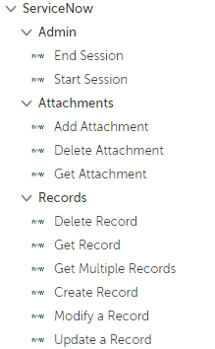

|  |  |  |
| --- | --- | --- |
| 1. Action | 1. Description | 1. Parameters |
| 1. Start Session | 1. Starts Session and authenticates with ServiceNow | |  |  | | --- | --- | | Session name | Name of session | | ServiceNow URL | Your ServiceNow Instance URL | | Client ID | Client ID Credential | | Client Secret | Client Secret Credential | | User Name | User name for account | | Password | Password | |
| 1. Add Attachment | 1. Adds an attachment to a record | |  |  | | --- | --- | | Session name | Name of session | | Table | Name of table where the record resides | | Sys_Id | Sys_id of the record in the target table | | File | File to attach to record | | Output Sys_id | Returns sys_id of the attachment that was created | |
| 1. Get Attachment | 1. Downloads attachment from record | |  |  | | --- | --- | | Session name | Name of session | | Sys_Id | Sys_id of file/attachment to download (note: this is NOT the sys_id of the record, but the sys_id of the *attachment*. Each entity in ServiceNow has a unique sys_id.) | |
| 1. Delete Attachment | 1. Deletes attachment from record | |  |  | | --- | --- | | Session name | Name of session | | Sys_Id | Sys_id of file/attachment to download (note: this is NOT the sys_id of the record, but the sys_id of the *attachment*. Each entity in ServiceNow has a unique sys_id.) | |
| 1. Get Multiple Records | 1. Returns a list of records from a table in ServiceNow | |  |  | | --- | --- | | Session name | Name of session | | Table | Table name | | Entry List – Values to return for each record in list | Enter the dictionary key that you would like to use for the output list of dictionaries. Then enter the ServiceNow key for the value you wish to retrieve (e.g. Dictionary key: “description”, ServiceNow key: “short_description” – this will specify each dictionary in the output list to have key “description” and it’s corresponding value will be the value of the ServiceNow record for “short_description”). See the [Table API documentation](https://developer.servicenow.com/dev.do#!/reference/api/rome/rest/c_TableAPI) from ServiceNow for more info on available keys from the response. Also see the example below. | | Output to List of Dictionaries | Each dictionary in list corresponds to one record, and the dictionary contains the keys specified in the entry list above. | |
| 1. Get Record | 1. Gets details for a single record from a table | |  |  | | --- | --- | | Session name | Name of session | | Table | Table name | | Sys_id | Sys_id of record to retrieve | | Entry List – Values to return for each record in list | Enter the dictionary key that you would like to use for the output dictionary. Then enter the ServiceNow key for the value you wish to retrieve (e.g. Dictionary key: “description”, ServiceNow key: “short_description” – this will specify the output dictionary to have key “description” and it’s corresponding value will be the value of the ServiceNow record for “short_description”). See the [Table API documentation](https://developer.servicenow.com/dev.do#!/reference/api/rome/rest/c_TableAPI) from ServiceNow for more info on available keys from the response. Also see the example below. | | Output to dictionary | The dictionary contains the keys specified in the entry list above. | |
| 1. Create Record | 1. Create new record in a table | |  |  | | --- | --- | | Session name | Name of session | | Table | Table name | | Values to include in record | Enter the valid ServiceNow key and the corresponding value in the entry list. For more information on available keys, please refer to the [Table API documentation](https://developer.servicenow.com/dev.do#!/reference/api/rome/rest/c_TableAPI). | | Output sys_id to String | Returns the sys_id of the newly created record in a string variable | |
| 1. Modify Record | 1. Modify record attributes (PUT method) | |  |  | | --- | --- | | Session name | Name of session | | Table | Table name | | Sys_id | Sys_id of the record to modify | | Values to include in record | Enter the valid ServiceNow key and the corresponding value in the entry list. For more information on available keys, please refer to the [Table API documentation](https://developer.servicenow.com/dev.do#!/reference/api/rome/rest/c_TableAPI). | | Output sys_id to String | Returns the sys_id of the newly created record in a string variable | |
| 1. Update Record | 1. Updates a record (PATCH method) | |  |  | | --- | --- | | Session name | Name of session | | Table | Table name | | Sys_id | Sys_id of the record to modify | | Values to include in record | Enter the valid ServiceNow key and the corresponding value in the entry list. For more information on available keys, please refer to the [Table API documentation](https://developer.servicenow.com/dev.do#!/reference/api/rome/rest/c_TableAPI). | | Output sys_id to String | Returns the sys_id of the newly created record in a string variable | |
| 1. Delete Record | 1. Delete a record | |  |  | | --- | --- | | Session name | Name of session | | Table | Table name | | Sys_id | Sys_id | |
| 1. End Session | 1. End session | |  |  | | --- | --- | | Session name | Name of session | |

**Triggers**

|  |  |  |
| --- | --- | --- |
| 1. Action | 1. Description | 1. Parameters |
| 1. New Incident | 1. Triggers when a new record is created in the Incident Table | |  |  | | --- | --- | | Session name | Name of session | | ServiceNow URL | Your ServiceNow Instance URL | | Client ID | Client ID Credential | | Client Secret | Client Secret Credential | | User Name | User name for account | | Password | Password | | Filter on Priority Level | Select priority level for incidents that should trigger the bot (only incidents created at or above the input priority level will initiate the trigger) | | Interval | Time interval to check for new incidents | | Assign output to record | Assign trigger data to a record with keys: triggerType, opened_at, number, description, sys_id and priority | |
| 1. Watch Incident | 1. Triggers when a specified incident is updated (i.e. a new comment is added) | |  |  | | --- | --- | | Session name | Name of session | | ServiceNow URL | Your ServiceNow Instance URL | | Client ID | Client ID Credential | | Client Secret | Client Secret Credential | | User Name | User name for account | | Password | Password | | Sys_id | Sys_id of the incident to monitor | | ServiceNow Time Zone | Time zone of ServiceNow instance – this is needed to detect when the update occurred – see ServiceNow documentation to retrieve the system time zone | | Interval | Time interval to check for new incidents | | Assign output to record | Assign trigger data to a record with keys: triggerType, opened_at, number, description, sys_id and priority | |

**Example of configuring the Get Multiple Records Action:**

The example below shows how to set up the action to retrieve up to 15 records from the incident table. Additionally, the output list of dictionaries will have the following keys available: ‘number’, ‘description’, ‘sys_id’, and ‘Open Since’. Each of those values is addressed in the ServiceNow response through the JSON dictionary keys of “number”, “short_description”, “sys_id” and “opened_at”, respectively (see example ServiceNow response below, Figure 2).

Figure 1 – Action Configuration for Get Multiple Records

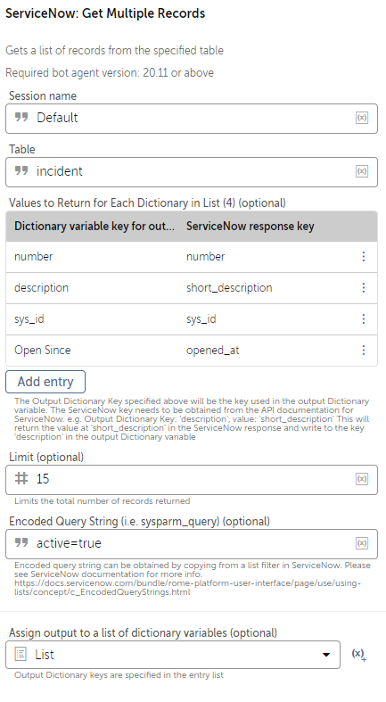

Figure 2 – ServiceNow Response Keys

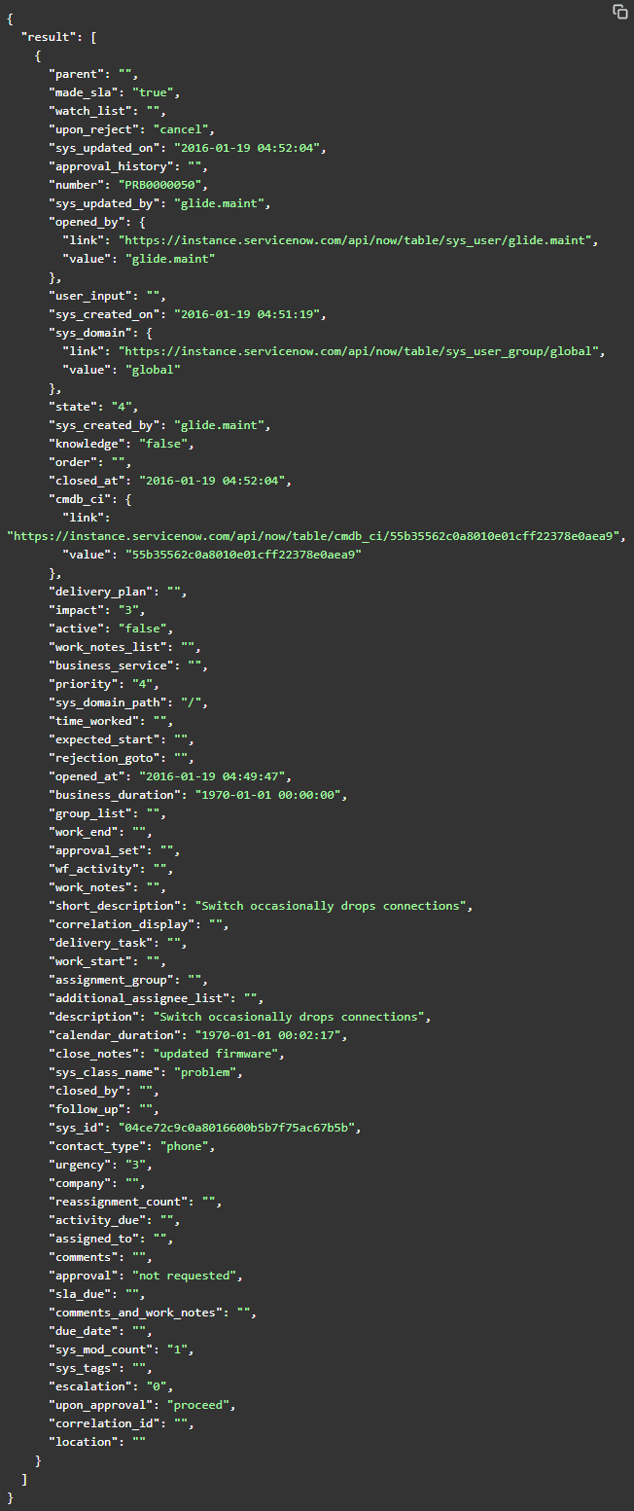

## Support & FAQs

### Support

Free bots are not officially supported. You can get access to Community Support through the following channels:

* You can get access to Community Support, connecting with other Automation Anywhere customers and developers on [APeople](https://apeople.automationanywhere.com/s/?language=en_US) – the [Bot Building Forum](https://apeople.automationanywhere.com/s/topic/0TO6F000000clDdWAI/bot-building?language=en_US), the [Bot Store Support Forum](https://apeople.automationanywhere.com/s/topic/0TO6F000000oT3rWAE/bot-store?language=en_US), or the [Developers Everywhere Group](https://apeople.automationanywhere.com/s/group/0F96F000000l23JSAQ/developers-everywhere?language=en_US).
* Automation Anywhere also provides a [Product Documentation portal](https://docs.automationanywhere.com/) which can be accessed for

more information about our products and guidance on [Enterprise A360](https://docs.automationanywhere.com/bundle/enterprise-v2019/page/enterprise-cloud/topics/release-notes/cloud-release-notes.html#Zj0vY2F0ZWdvcnkvZXhwbG9yZT9wPUV4cGxvcmU=).

### FAQs

For questions relating to Enterprise A360: See the [Enterprise A360FAQs](https://docs.automationanywhere.com/bundle/enterprise-v2019/page/enterprise-cloud/topics/release-notes/cloud-A2019-faq.html#Zj0vY2F0ZWdvcnkvZXhwbG9yZT9wPUV4cGxvcmU=).

Appendix A: Record of Changes

|  |  |  |  |  |
| --- | --- | --- | --- | --- |
| No. | Version Number | Date of Change | Author | Notes |
| 1 | 1.0.0 | 09/20/2021 | J Dickson | Initial Release |

Appendix B: References

|  |  |  |
| --- | --- | --- |
| **No.** | **Topic** | **Reference Link** |
| 1 | Overview of Enterprise A360 | Click [here](https://docs.automationanywhere.com/bundle/enterprise-v2019/page/enterprise-cloud/topics/aae-client/bot-creator/using-the-workbench/cloud-explore.html#Zj0vY2F0ZWdvcnkvZXhwbG9yZT9wPUV4cGxvcmU=) |
| 2 | Guidance: Building basic A360 bots | Click [here](https://docs.automationanywhere.com/bundle/enterprise-v2019/page/enterprise-cloud/topics/aae-client/bot-creator/using-the-workbench/cloud-how-to-build-and-edit-bots.html#Zj0vY2F0ZWdvcnkvYnVpbGQ/cD1CdWlsZA==) |
| 3 | Guidance: Building A360 action packages | Click [here](https://docs.automationanywhere.com/bundle/enterprise-v2019/page/enterprise-cloud/topics/developer/cloud-create-package-overview.html#Zj0vY2F0ZWdvcnkvYnVpbGQ/cD1CdWlsZA==) |
| 4 | APeople Community Forum | Click [here](https://apeople.automationanywhere.com/s/?language=en_US) |
| 5 | Automation Anywhere University | Click [here](https://university.automationanywhere.com/b) |